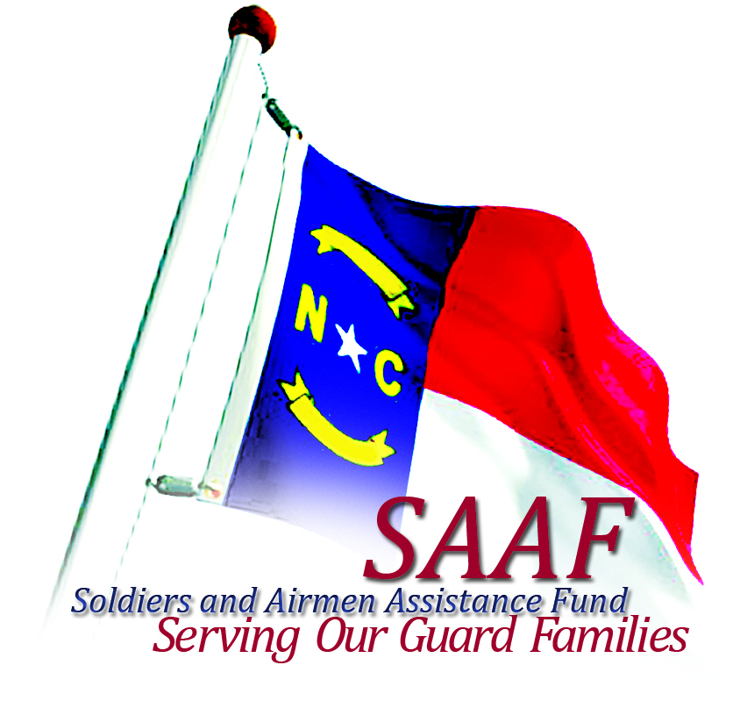
“Helping the Guard Take Care of Its Own”
Soldiers and Airmen Assistance Fund, Inc.

Since 9/11, the North Carolina National Guard has deployed nearly 20,000 Soldiers and Airmen. Like those before you, citizen soldiers have always proudly answered the call of our nation to defend it. To show you how much we appreciate your service to our country, I am proud to announce to you that a new, patriotic license plate has been designed in your honor and is now available in NC.
It is the most patriotic plate available in our state! The updated plate design features In God We Trust (the official motto of the US), the American Eagle (the national emblem, symbol of freedom, authority and power), in the background, the US Flag (the most recognized symbol of our country), the letters S and A (stands for Soldiers and Airmen) in the NC National Guard, and North Carolina in red (representing the energy and strength of our great state). “The theme of this plate is certainly a true expression of our patriotism. Our goal was to design a plate that every North Carolinian would be proud to put on their vehicle; a plate that would express how they feel as Americans and to show their support for our Guard families at the same time,” said Dennis Roach, Director of the SAAF. “It’s a great looking plate with a definite message! I am an American, proud of it and I support our troops!
Now, we encourage you to help your fellow Guardsmen by purchasing the “In God We Trust” license plate and showing everyone why you wear the uniform. You can also help us by telling your friends, coworkers, etc., that a new patriotic license plate is now available in NC. The plates cost only $30 plus vehicle registration fees, and for each plate sold, a $20 tax-deductible donation is sent to the SAAF. As you know, Power is in numbers and the more plates purchased will help provide much needed funds to support our Guard families now and in the future.
American Spirit • Pride • Patriotism 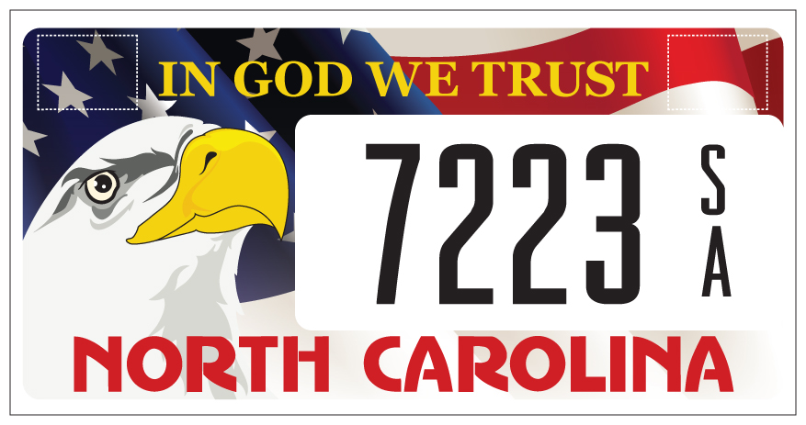
It’s fast, easy and a great way to show your support!
To order your
“IN GOD WE TRUST”
License plate, stop in at your local DMV office or visit the NCDMV website www.ncdot.gov/dmv, Online Services, Specialized Plates
Or
Visit our website at
www.saaf-nc.com/license-plate

